**КИЇВСЬКИЙ ФАХОВИЙ КОЛЕДЖ ЗВ’ЯЗКУ**

**WORK-CASE №5**

з дисципліни «Операційні системи»

Виконали: студенти **3** курсу, групи **КСМ-13А**

**Засенко Олександр**

(прізвище та ініціали)

**Дзюбенко Дмитро**

(прізвище та ініціали)

**Сторожук Костянтин**

(прізвище та ініціали)

Київ  2023

**ЗМІСТ**

How to connect……………………………………………………...………….....……..3

Connecting a flash drive………………………………………………..……….……….5

Connecting a printer……………………………………………………………..………8

How to print a text file ……………………..………………………………………...…10

Conclusions.……………………………………………………………………………..11

***The material was prepared by a student Zasenko***  
When working with the main Linux operating system, there is a built-in mechanism for interacting with peripherals, such as printers and flash drives, which includes the following steps:

1. **Connect a physical device:** When you insert a flash drive or connect a printer via the USB port, the Linux kernel immediately detects the device and starts processing it.
2. **Device recognition:** Linux attempts to identify the connected device based on identifying information such as manufacturer and product identifiers for USB devices. Once recognized, the kernel determines which driver or subsystem needs to be activated to process the device.
3. **Loading drivers:** The Linux kernel automatically or at the user's request loads the appropriate driver for the device. Drivers are programs that enable interaction between the operating system and specific devices.
4. **Creating virtual file devices:** Linux creates a virtual file interface that mirrors the physical device in the system. For example, for a flash drive, this can be represented as a special file in the /dev directory that the user can use to access the data on the flash drive.
5. **Mounting the flash drive:** The user has the option to manually or automatically mount the flash drive to the system in order to access its contents through the appropriate directory.
6. **Printing from the printer:** For printers, the kernel sends information about the print job to the print server (e.g. CUPS). CUPS is responsible for managing the print jobs and sending them to the appropriate printer.
7. **Hardware management:** Users have the ability to use a variety of commands and tools to manage connected hardware such as flash drives or printers. For example, you can use the mount and umount commands to work with a flash drive, and the tools provided by the print server to manage a printer. This mechanism makes it easier for users to connect and use peripherals on Linux.

Mounting is a procedure that allows you to attach a file system (for example, a physical device or network share) to the directory hierarchy in the operating system, providing convenient access to its contents through a specific directory. The main purpose of mounting is to allow users to easily interact with data on these devices or resources.

It is based on the following steps:

1. **Determine the source:** First, you select the file system you want to connect. This can be a physical device (for example, a flash drive or hard disk) or a network share (for example, a folder on another computer on the network).
2. **Select a directory for mounting:** The user or system defines the folder to which the file system will be attached. This folder will serve as a gateway to access the contents of the source.
3. **Performing the mount operation:** The actual mounting operation is performed through special commands or the operating system interface. As a result, the source content becomes available in the selected folder.

Mounting is used for various purposes:

* Provide access to external devices, such as flash drives or external hard drives.
* Access network resources, such as files and folders on other computers or servers.
* Organize the file system hierarchy and manage different data sources.
* Ensure security and limited access to file resources.
* Improve the convenience and organization of user workflow.

When interacting with peripherals, such as printers, flash drives, and other devices, Linux and Windows operating systems have different approaches and functionality:

1. **Drivers:**

* **Linux:** In Linux, many drivers are already built into the kernel or available as modules. Typically, many devices work out of the box without the need to install additional drivers. If necessary, the user can enable or add the required driver.
* **Windows:** On Windows, it is often necessary to install separate drivers for most devices. The operating system provides a large database of drivers, and many of them are automatically installed from the Internet when the device is connected.

1. **Representation of the file system:**

* **Linux:** In Linux, the file system is represented as a directory tree, where each device can be connected to a specific directory. For example, a USB flash drive can be plugged into /mnt/usb and be accessed through this path.
* **Windows:** In Windows, each device is given a letter designation, such as "D:" for a flash drive or "C:" for a hard disk. Users interact with devices through letter names, which can be convenient for many.

1. **Methods of management:**

* **Linux:** On Linux, managing peripherals is usually done through the command line or configuration interfaces such as Device Management. This may require some level of technical expertise.
* **Windows:** Windows provides more user-friendly graphical interfaces for configuring and managing peripherals, which may be more appealing to users with less technical expertise.

1. **Licensing and cost:**

* **Linux:** Linux is a free and open source operating system available for free and does not require a license.
* **Windows:** The cost of Windows varies depending on the version and requires the purchase of a license.

***The material was prepared by a student Dziubenko***

Task: Connect a USB flash drive and a printer (if possible) to your Linux virtual machine and use the GUI to copy one file from the flash drive to the virtual machine and print it (repeat the same steps with another file and using commands in the terminal).

To connect to your virtual machine with Linux installed, you need a flash drive and a printer: - Depending on the version of VirtualBox you have installed, you need to install the "VBox Extension Pack" add-on on the official website of the VirtualBox project.

To find out the version, follow these steps - Open VBox -> In the top sliders, select Help -> About VirtualBox -> There you will see the version you need.

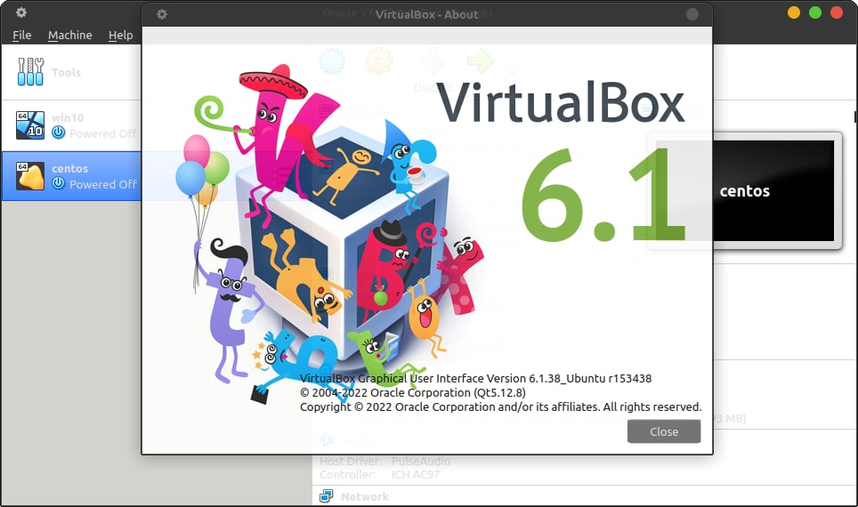

Fig 1. Opening VBox

After that, in your browser, search for vbox extension pack, the first site will be offline. On this site, find VirtualBox older builds where you will find your current version of vbox and install the extension pack.

After the installation, open vbox -> File -> Preferences -> Extensions -> and paste the previously installed extension file.

Next, in the settings of your virtual machine there will be 3 items - USB 1,2,3. In my case, I chose USB 2 and added a flash drive.

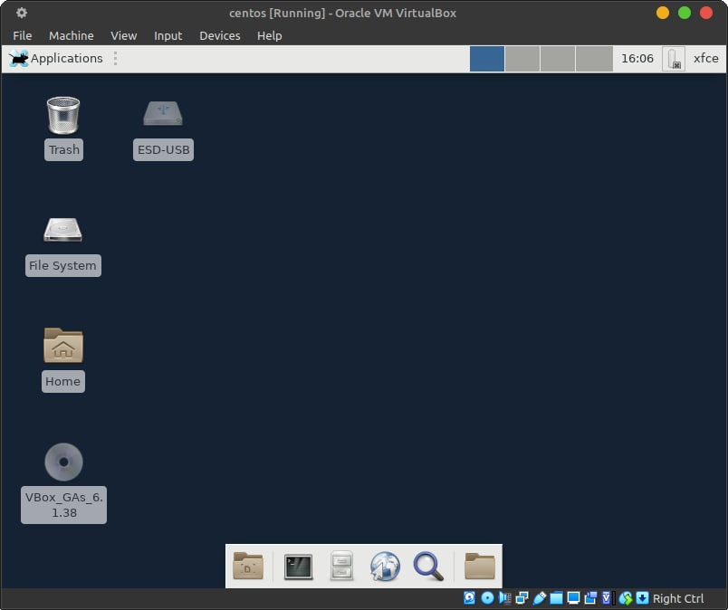

Fig 2. The label of your flash drive

If you have followed the steps above, you will see a shortcut to your USB flash drive on the desktop when you start the virtual machine.

To add a printer in the virtual machine configuration menu, add your printer in the USB directory.

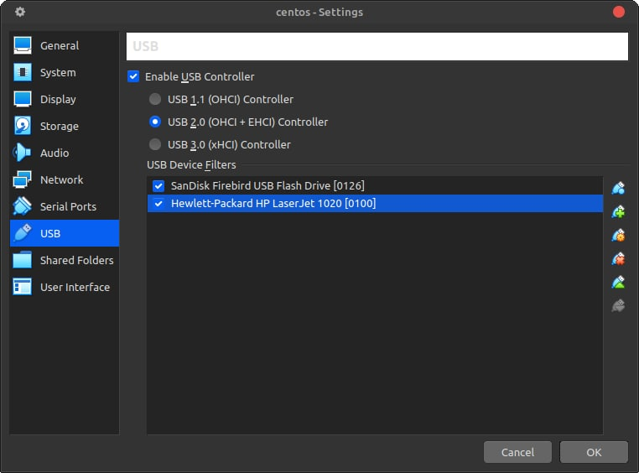

Fig 3. Adding a printer

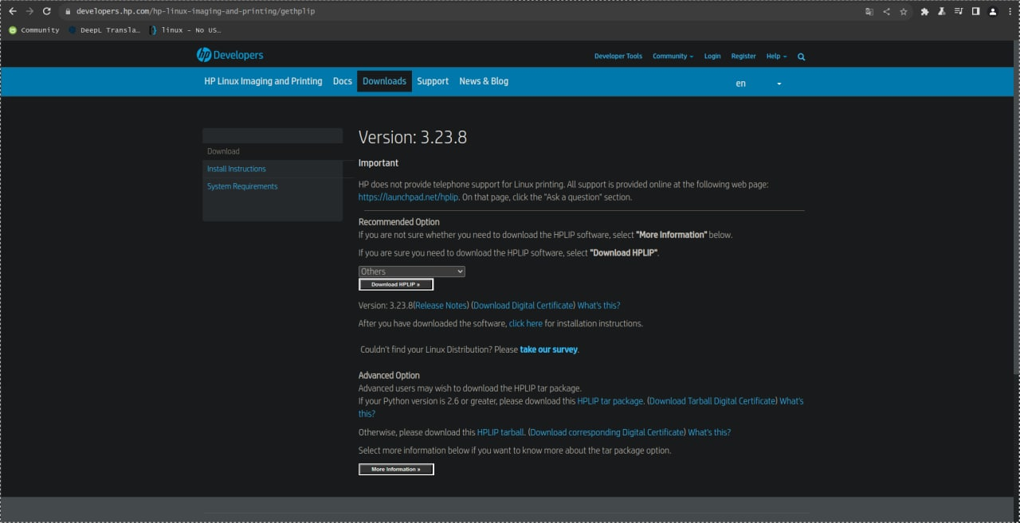

Fig 4. Your printer manufacturer's website

To install the drivers, log in to the website of your printer manufacturer and download the driver for the required OS.

To mount the disk, double-click on the label of your disk that you added earlier.

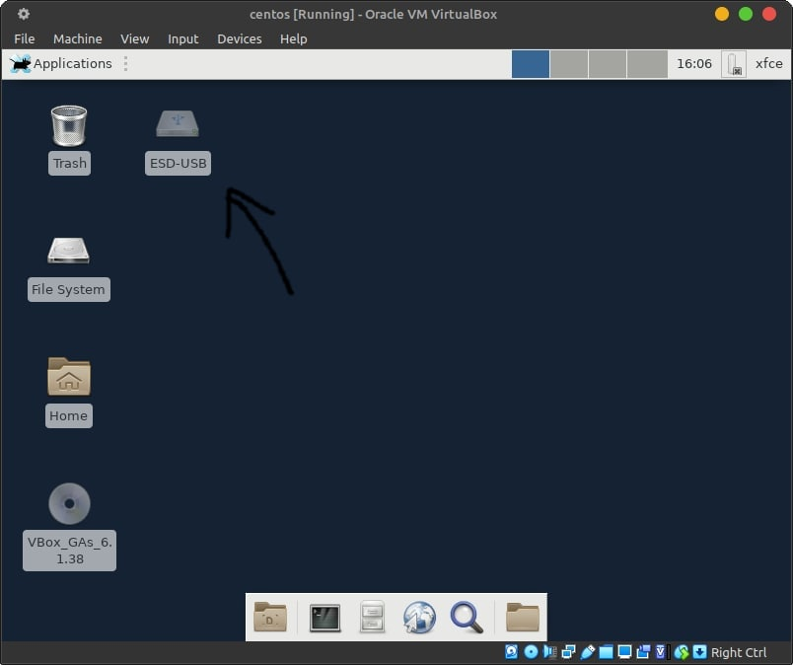

Fig 5. Open the directory with your flash drive

You will see a directory with your flash drive. In it, use the combination Crtl + S, Ctrl + V.

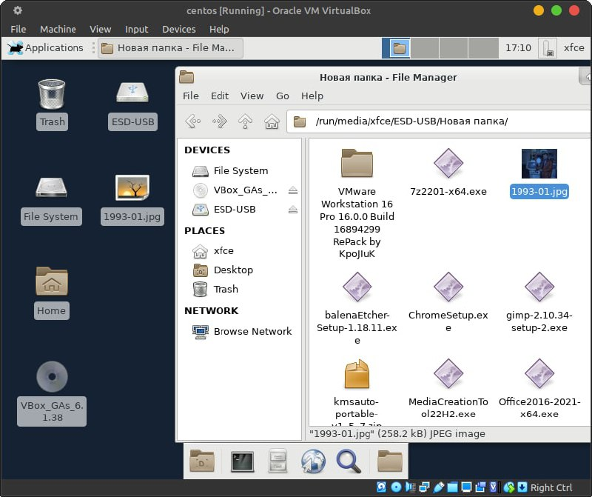

Fig 6. Use the combination Crtl + S, Ctrl + V

When you open Printer Settings from the system's search menu, you can see your printer set up and ready to go.

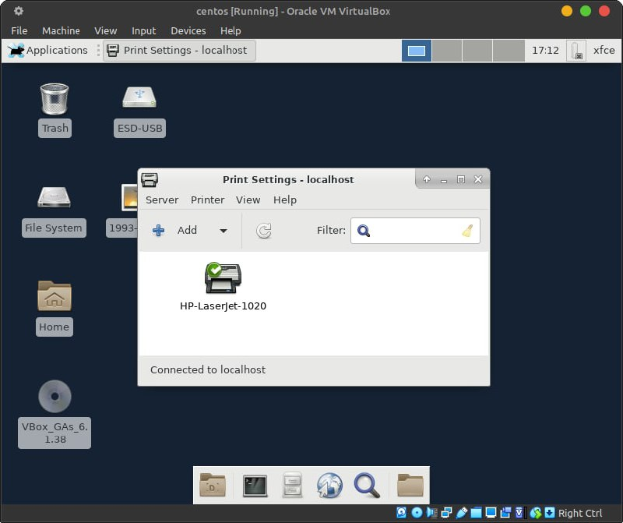

Fig 7. Printer settings menu

In order to print a text file or a picture (in our case). You need to open the picture by double-clicking with the left mouse button and click Print. In the current window, select your printer and settings to print the desired file.

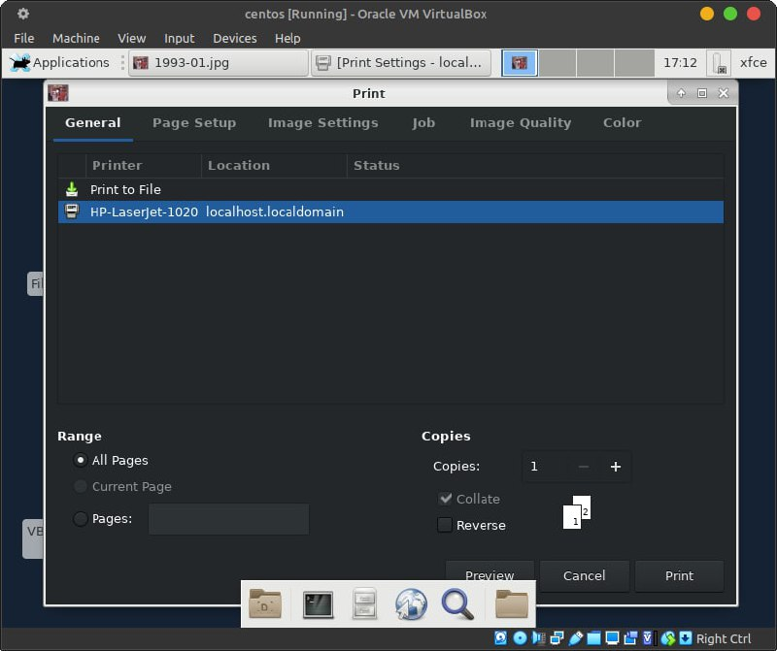

Fig 8. Opening picture

To print a text file through the terminal, you can use the lp command. lp file name.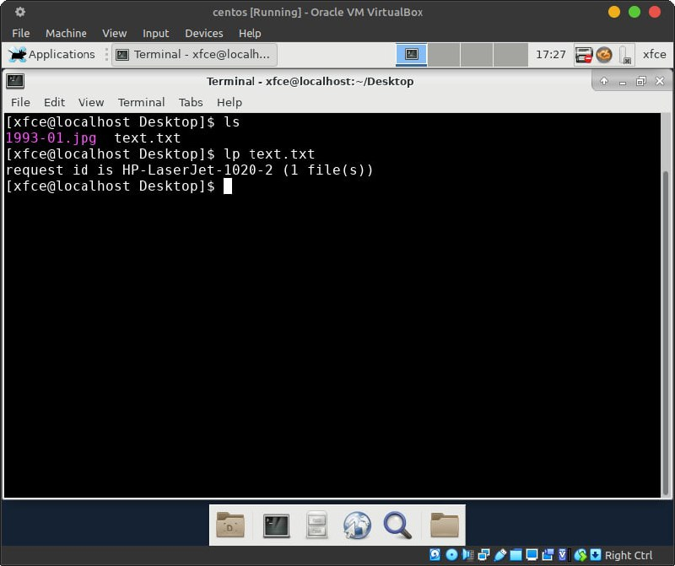

Fig 9. The lp command

**Conclusions**

***The material was prepared by a student Storozhuk***

In this article, we learned how to connect a flash drive and a printer to a Linux OS installed on VirtualBox. We also learned how to print images and text using the console. We encountered only one problem when the computer did not see the flash drive, but it was a problem with the flash drive because it was old.